# **Custom Query Copy from DataBase with:**

1- Add a “Copy Activity”:

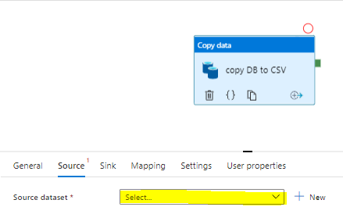

2 – Select your source Data set – presumably, a SQL connector. Click on open to check the Characteristics

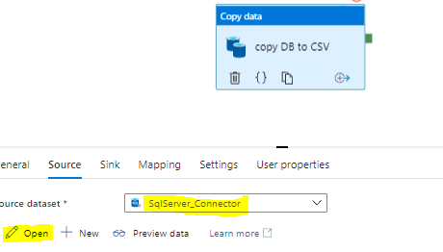

3 – Select your linked service and “none” in the table (this way you can enter your custom query):

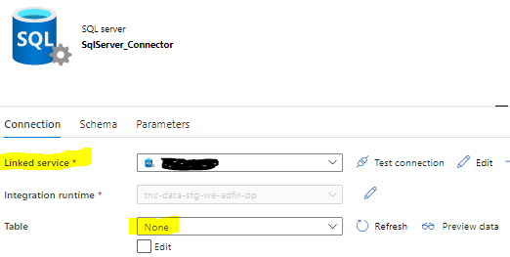

4 – Your linked service connects to the DataBase via your “integration runtime”. It needs your credentials which usually are provided via Azure keyvault.

5 – “Sink” is the destination of your data (click in open to modify)

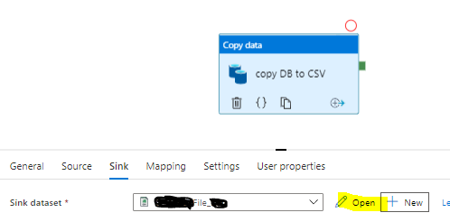

6 – Select the output file attributes such as compression type, delimiter your datalake, path and filename. Select also “Quate character” 🡪 “No quote character” and Null value “” (double quotes)

